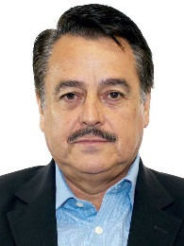
Dip. Alfredo Femat Bañuelos
Presidente
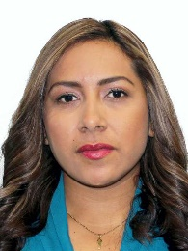
Dip. Maria del Carmen Bautista Peláez
Secretaria
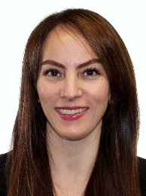
Dip. Gabriela Cuevas Barron
Secretaria
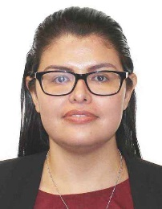
Dip. Miriam Citlally Pérez Mackintosh
Secretaria
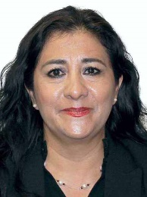
Dip. Beatriz Silvia Robles Gutiérrez
Secretaria
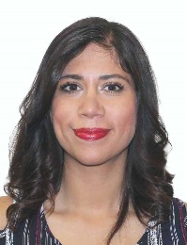
Dip. Teresita de Jesús Vargas Meraz
Secretaria
Dip. Sarai Núñez Cerón
Secretaria
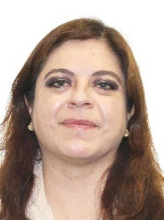
Dip. Hortensia María Luisa Noroña Quezada
Secretaria
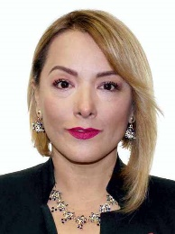
Dip. Claudia Angélica Domínguez Vázquez
Secretaria
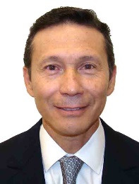
Dip. Jorge Francisco Corona Méndez
Secretario
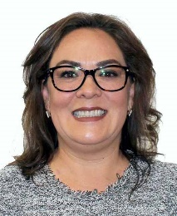
Dip. Claudia Báez Ruiz
Integrante
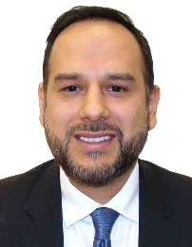
Dip. Carlos Elhier Cinta Rodríguez
Integrante
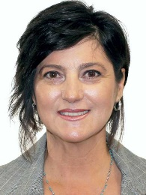
Dip. Olga Juliana Elizondo Guerra
Integrante
Dip. José Luis Elorza Flores
Integrante
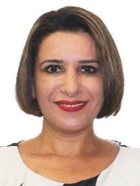
Dip. Mariana Dunyaska García Rojas
Integrante
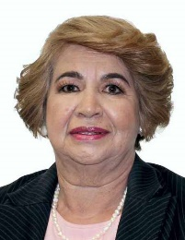
Dip. María Libier González Anaya
Integrante
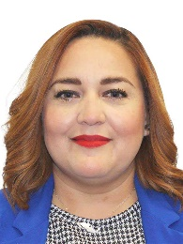
Dip. Annia Sarahí Gómez Cárdenas
Integrante
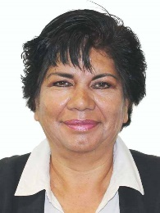
Dip. María Eugenia Hernández Pérez
Integrante
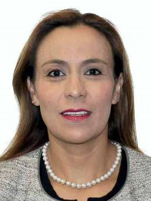
Dip. Pilar Lozano Mac Donald
Integrante
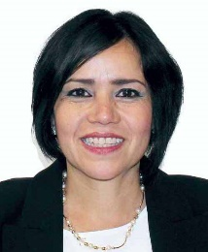
Dip. Mirna Zabeida Maldonado Tapia
Integrante
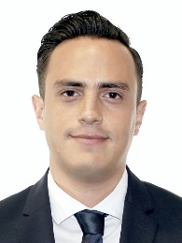
Dip. Oscar Daniel Martínez Terrazas
Integrante
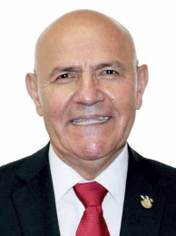
Dip. Benito Medina Herrera
Integrante
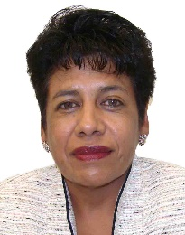
Dip. María de Lourdes Montes Hernández
Integrante
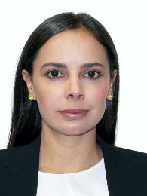
Dip. Ana Patricia Peralta de la Peña
Integrante
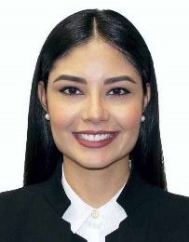
Dip. María Geraldine Ponce Méndez
Integrante
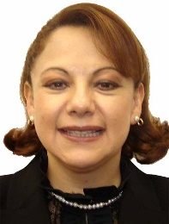
Dip. Claudia Pérez Rodríguez
Integrante
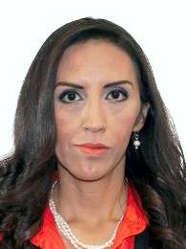
Dip. Laura Imelda Pérez Segura
Integrante
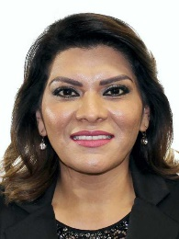
Dip. Lorenia Iveth Valles Sampedro
Integrante
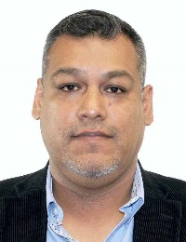
Dip. Alberto Villa Villegas
Integrante
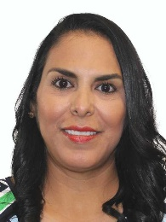
Dip. Mirtha Iliana Villalvazo Amaya
Integrante
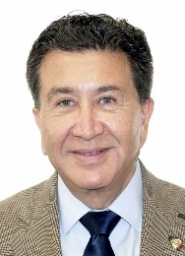
Dip. Héctor Yunes Landa
Integrante
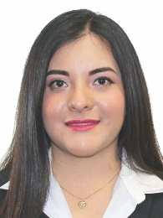
Dip. Xochitl Nashielly Zagal Ramírez
Integrante

